|  |  |
| --- | --- |
|  | Catoosa Wildlife Management Area & Nemo |

|  |  |  |
| --- | --- | --- |
| Summary | Catoosa Wildlife Management Area is a large game-management area on the Upper Cumberland Plateau in Morgan, Cumberland and Fentress counties in Tennessee in the United States. It comprises 82,000 acres of wild land administered by the Tennessee Wildlife Resources Agency.  **Hours:** day light hours  **Seasonality**: year round  **Fees:** none  **Updated 9/15/2019** | Image result for wildlife management area icon |
| Entrance | **Wartburg Entrance**  Take Catoosa Road from Wartburg to Old Catoosa Campground, eight miles. Once inside the WMA, there are several campgrounds, wildlife and scenic opportunities.  If you would like more information, you should go to the check-in station via the following directions. Turn left at Catoosa Campground. Go five miles to Bi-color Station.  **Peavine Rd Entrance**  From I-40, exit 322, Peavine Rd, travel north on Peavine Rd for 1.8 miles and make a left onto Firetower Rd. Once on Firetower Rd, travel 2.8 miles to the end of pavement and continue 0.6 miles more to a gate (Google maps show the road as Otter Creek Rd).  This is the entrance to Catoosa WMA. Follow the road 3.1 miles to the savanna restoration site. Travel 8.2 miles past the gate to the Devil's Breakfast Table area (or 14.7 miles from turning onto Firetower Rd). |  |
| Sites | **Nemo Train Bridge**  This bridge is part of the Cumberland Trail System.  “One 180-foot Camelback, two 149 foot Camelback spans. Each span is a pin-connected Camelback through truss.. pin connections were very unusual on a span of this type in 1929, normally they were on earlier truss spans. The two 149-foot truss spans, the second incline contains only one panel, while the 180-span has the more typical two-panel incline. West abutment is masonry, east abutment is masonry with a concrete camp, denoting they were built for the 1906 spans. Top chords, end posts and veticals are channels with lacing. Bottom chords and diagonals are paired rectilinear eyebars, and the counters are single cylindrical tie rods.”  **Tunnel # 24 “Nemo Tunnel”**  “Tunnel 24 was bored in 1878, and carried the CNO&TP/CS through the mountain at Nemo, Tennessee. A small depot was located south of the south portal. Beside the depot, was a switch to the Morgan & Fentress Railroad. On top of the portal once stood two homes. There was also a height brush about 1000ft from the portal, to warn any brakemen on top of the cars (a 1800's practice) that there was a low clearance approaching. Today, all of the above listed are gone. The homes, depot, and M&F Railroad are all gone. M&F's tracks were pulled after a 1949 flood destroyed their bridge over the Emory River. In 1963 CNO&TP successor and lease holder Southern Railway began moving forward with plans to eliminate, bypass or raise the remaining 10+ tunnels on the CNO&TP.  Due to increasing rail car height, the 15X20 measurements were not generous enough and posed restrictions on shipments on this vital rail corridor. Plans were drawn up to bypass 24, and Nemo sister tunnels 23 and 22 with two new tunnels. The alignment of such may be viewed on the Google Map. The new tunnels are 20X30, much larger than the old tunnels.  Today, the tunnel sits empty beside the new 24, which Southern Railway successor and lease holder Norfolk Southern uses daily. It is almost completely intact, with minor damage being a collapsed, but cleared, north portal. The interior sees minor water buildup on the south end, however dries out half way through. For years off roaders have enjoyed the tunnel, and it is quite neat to explore if you're a history buff. The current owner of the tunnel is not known, as Norfolk Southern has the current tracks well over 700 feet from this tunnel, however some are not sure if it was possible for Southern to get rid of a tunnel the City owns.” |  |
| Touring | Auto viewing is recommended through the Catoosa WFA. Most roads are dirt and gravel with easy to moderate skills required. Bring your camera! |  |
| Hiking | Hiking opportunities are plentiful with over 110 miles of gravel road and 150 miles of logging roads. Some short hiking trails are present.  **Cumberland Trail is the most noteworthy.**  Devil’s Breakfast Table  Nemo Trail |  |
| Camping | Overnight camping is allowed on designated areas in the WMA. The area is closed to entry between sunset and sunrise.  Rock Creek Campground is $10 per night and requires a reservation. <https://www.nps.gov/obed/planyourvisit/campgrounds.htm> |  |
| Wildlife | The oak savanna area provides habitat for uncommon birds on the Cumberland Plateau, including Red-headed Woodpecker (very high densities), Prairie Warbler, Yellow-breasted Chat, White-eyed Vireo, and Common Yellowthroat.  Thick streamside may yield a Swainson's Warbler, Louisiana Waterthrush, or a river otter. Wild Turkey, White-tailed Deer, and Ruffed Grouse are present. |  |
| Alerts | **Ticks are abundant nearly year round, so be warned!**  **Tennessee is home to four venomous snakes**  Northern and Southern Copperhead, Timber Rattlesnake, Western Pygmy Rattlesnake, and Western Cottonmouth, but most people rarely see them. Always check before putting your hands in cracks and crevices, and practice caution when hiking in rocky areas. If you do see a snake, it is safest for you and the snake to leave it alone.  **Poison ivy, oak, and sumac**  Wear light-colored clothing to increase your ability to spot ticks on you. Wear protection against the sun, such as lotion and a hat, to prevent sunburn. |  |
| Links | Google Maps – Catoosa WMA  <https://drive.google.com/open?id=1JUVuO0EZq72NWC92B_znMsETiCzWLezx&usp=sharing>  Resources and more information!  All information and content found through the following links. Additional sources provided for more information and exploration!  Morgan County  <http://www.morgancountychamber.com/catoosa-wildlife-management-area/>  Easy off-roading  <https://easyoffroading.com/index.php/2019/05/28/nemo-abandoned-train-tunnels-in-catoosa-national-forest-tn/>  Bridge Hunter  <https://bridgehunter.com/tn/morgan/nemo/>  <https://bridgehunter.com/tn/morgan/bh54665/>  Tennessee Wildlife Resources  <https://www.tn.gov/twra/hunting/wildlife-management-areas.html>  Tennessee Watchable Wilflife  <http://www.tnwatchablewildlife.org/watchareadetails.cfm?uid=09071608221137880&region=Catoosa_WMA_&statearea=East_Tennessee>  [Red-headed Woodpecker](https://www.tn.gov/content/tn/twra/wildlife/birds/red-headed-woodpecker.html) (very high densities), [Prairie Warbler,](https://www.tn.gov/content/tn/twra/wildlife/birds/prairie-warbler.html) [Yellow-breasted Chat](https://www.tn.gov/content/tn/twra/wildlife/birds/yellow-breasted-chat.html), [White-eyed Vireo,](https://www.tn.gov/content/tn/twra/wildlife/birds/forest-birds/white-eyed-vireo.html) and [Common Yellowthroat](https://www.tn.gov/content/tn/twra/wildlife/birds/common-yellowthroat.html)  [Swainson's Warbler](https://www.tn.gov/content/tn/twra/wildlife/birds/swainsons-warbler.html), [Louisiana Waterthrush](https://www.tn.gov/content/tn/twra/wildlife/birds/louisiana-waterthrush.html), or a river otter. [Wild Turkey](https://www.tn.gov/content/tn/twra/wildlife/birds/wild-turkey.html), W[hite-tailed Deer,](https://www.tn.gov/content/tn/twra/wildlife/mammals/large/deer.html) and [Ruffed Grouse](https://www.tn.gov/content/tn/twra/wildlife/birds/ruffed-grouse.html) are present |  |

## Tips for safely watching wildlife during hunting seasons and year round…

**1. Be respectful and courteous to hunters and other outdoor users on WMA's and other public lands.** Tennessee sportsmen contribute the vast majority of TWRA's funding, which ensures the successful management of wildlife for the benefit of all Tennesseans to enjoy.

**2. Be mindful of areas that allow hunting, especially on opening weekends.** The best way to stay safe during hunting season is to be aware of areas where hunting is allowed during hunting seasons. Hunting is often allowed on Wildlife Management Areas (WMA), National Wildlife Refuges (NWR), and National Forests, although hunting dates vary by location, some waterfowl refuges are closed to all forms of trespass in winter, while hunting is allowed at other sites only on certain days. During hunting seasons, consider watching wildlife and hiking on trails in National Parks, State Parks, State Natural Areas, and city parks where hunting is generally not allowed. There are observations areas, viewing towers, and trails open year round on some Wildlife Management Areas. Some WMA's are closed to all uses except hunting during scheduled hunts. These closures typically occur during the peak fall hunting seasons (October - December), and spring turkey hunting season (April - mid-May). Please visit the [**TWRA website**](http://www.state.tn.us/twra/) for the Hunting Guide with information on access dates on all WMA's.

**3. Wear bright colors.** If you decide to watch wildlife or hike in an area where hunters may be present, be sure to wear bright colors, especially orange and yellow (avoid white). Big game hunters, by state law, are required to wear at least 500 square inches of fluorescent orange when hunting deer, bear, which is achieved with a hat and vest. Non-hunters should follow the same rules, especially when hiking in areas when encountering hunters is possible.

**4. Identify Yourself.** If you see someone hunting and are not sure if they see you, make distinguishing noises only humans make. Most hunters appreciate knowing when someone else is in the area that they are hunting. While these noises might upset some hunters, safety is the most important priority for TWRA in the management of our public lands.

*(Source cited in links.)*

**Catoosa Wildlife Management Overview**

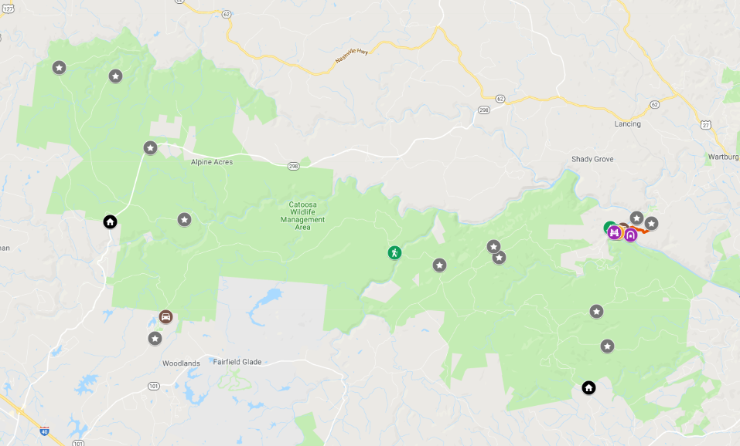

notlikeweplanned.com

**Nemo Bridge & Tunnel**

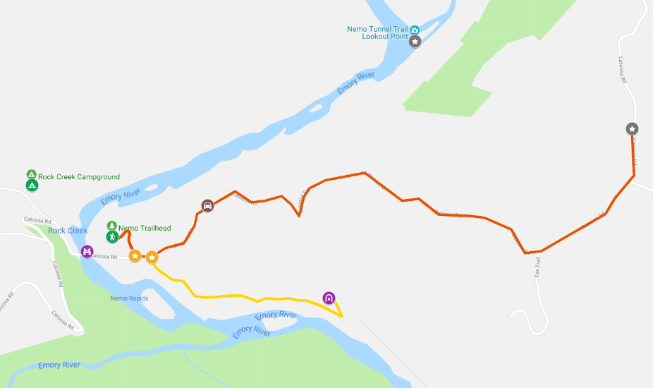

notlikeweplanned.com